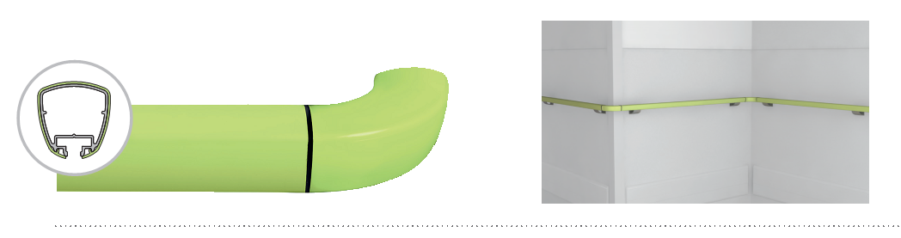
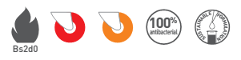


SPECIFICATION

LINEA’TOUCH & LINEA’TOUCH+
PVC SHEATHED
TRILOBED HANDRAIL - 40 MM WIDTH

- Description: trilobed handrail with antibacterial PVC sheath (Linea’Touch or Linea’Touch+ - PVC sheathed as manufactured by SPM) with a cross section from 28 to 40 mm to give it an ergonomic and anti-rotation design. It is 42 mm high and projects 80 mm from the wall (or 90 mm on request). It consists of a 2 mm thick continuous aluminium profile, or a 5 mm one for the reinforced version, covered by a 2 mm thick smooth and antibacterial, PVC sheath, achieving Bs2d0 fire-rating with solid colour, and a closer underneath. A protective film is specified to minimise cleaning before acceptance. The section comprises a groove into which brackets and closer slide and lock. Wall fixing is by silver anodised effect aluminium brackets with 2-point self-locking: 20 mm wide refined bracket or 55 mm wide bugled bracket (for Linea Touch) or 80 mm wide reinforced bracket (for the reinforced Linea’Touch+). The axial position of the brackets provides an excellent guiding. Various smooth and antibacterial PVC accessories with solid colour (flat or beveled endcaps, classic or extended and curved wall returns), supplied with bactericidal joints, are available to finish the handrail assembly and are sleeved into the profile. All technical solutions are available to ensure continuity around corners (90° or made-to-measure), in staircases (3-way “universal joint” rotation angle -Rapid’Angle® as manufactured by SPM), across service ducts (quick removable assembly wedge) and around curved sections (pre-curved in the factory). These handrails achieve an impact resistance in excess of 70 Joules -i.e. an impact of more than 220 kg travelling at 2 kmh- (for Linea’Touch) and of 110 Joules -i.e. an impact of more than 320 kg travelling at 2 kmh- (for the reinforced version Linea’Touch+).
- Environment: no heavy metals and no substance potentially subjected to any REACH restriction are used in its manufacture, nor PBT/BPA. The calcium-zinc thermal stabilization process is used. The emission level of volatile substance in inside air has been tested according to ISO 16000-6 and is very low (A+) according to the French regulation (23 March 2011 nr 2011-321 Decree and 19 April 2011 Order). 100% of the product are recyclable.
- Colour: selected by architects from manufacturer’s standard range.
- Installation method: upper edge of section 0.90 m max. above floor level. Fixes to 2-point self-locking aluminium brackets screwed to the wall at 1.20 m centres (0.80 m centres in heavy traffic corridors and on light partitions like plasterboard). Wall returns, endcaps and angles to be fixed with 2.5 mm Allen clamping screws.
